Pistol grip operation instruction
- Button definition
- Power switch: Turn on means shut pistol grip, down means open it.

- Scanner button: when the pistol grip connected with machine successfully, press scanner button can scan 1D/2D barcode.

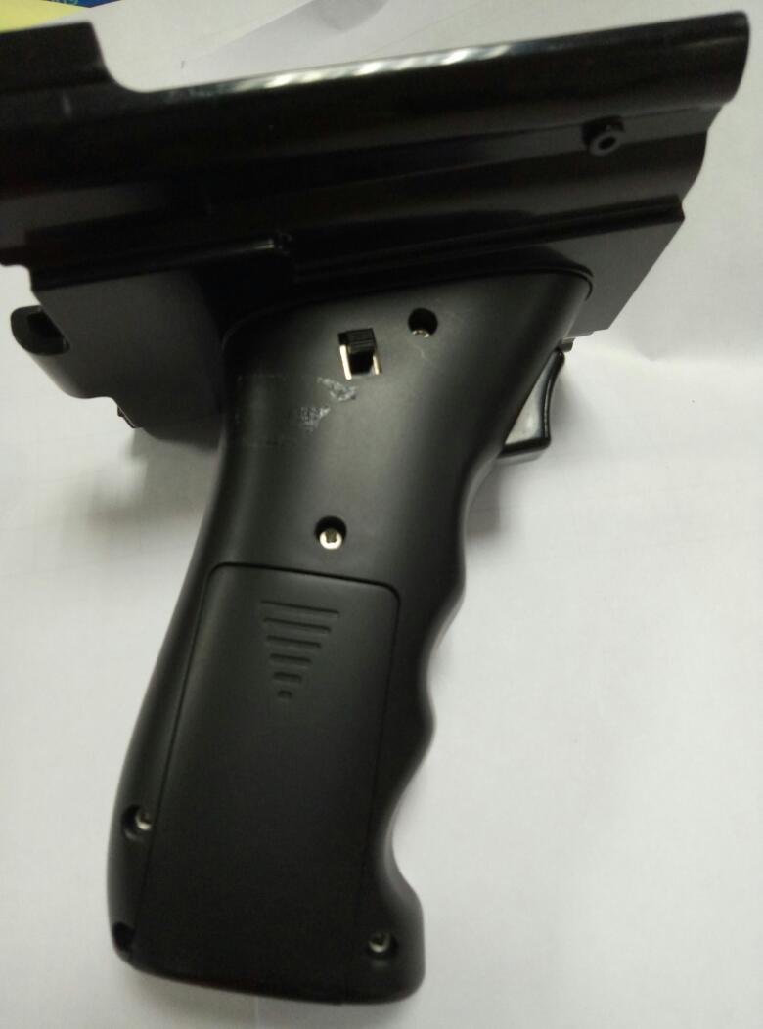
Scanner button
Power switch
- Light definition
- LED light off means pistol grip is shut.

- LED light on means pistol grip is successfully connected with machine.

- LED light flicker at 1 second interval means pistol grip is open but is not connected successfully.

- LED lights interval 0.5S continuous flashing: that machine is clear paired equipment information, to easy to connect the next device.

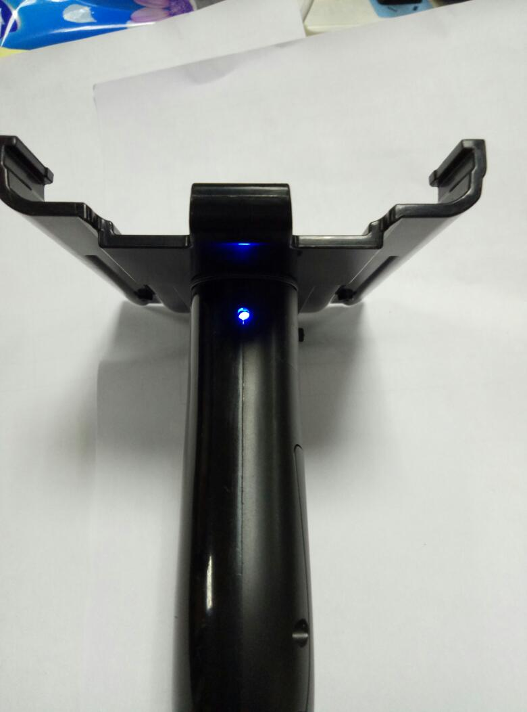
LED light
- Scan Application(just for I62H WIN10,for Android, please go to step5 directly)
- As followed picture, enter scan application home page .setup_v1.1.5.0(Version number)，Select run as an administrator. As followed.
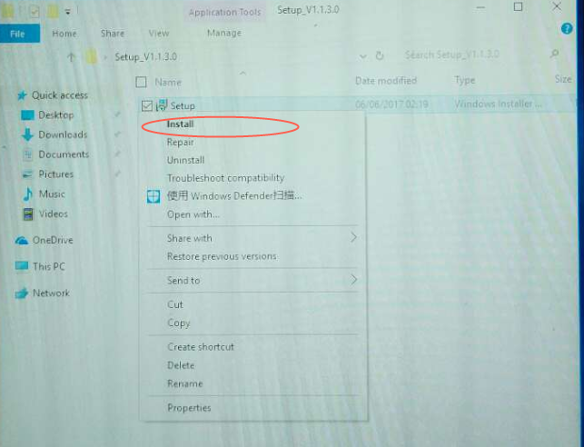

- When finished application install, desktop or bottom status bar will show Shortcut icon.

Remark: If above Shortcut icon is only show on desktop not appear at bottom status bar, please double click ,restart this application.(Not restart machine, just restart this application)

- Open Shortcut icon at bottom status bar to run it, as followed:
Serialport：default com1，
baudRate：1D code module choose 9600, 2D code module choose 115200.
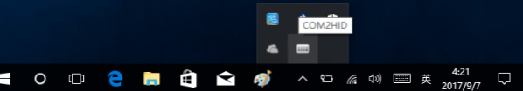

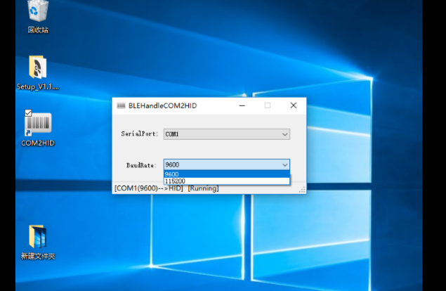

- Bluetooth and pistol grip connect(The instruction is based ib RS2 for reference)
- All setting-Device

- Click Bluetooth to enter BT mean. Turn on power switch, search “BLE_Handle” to connect, when shows “connected”, device is connected successfully.

- Connected successfully, this blue light is turn on, press scan button to scan barcode

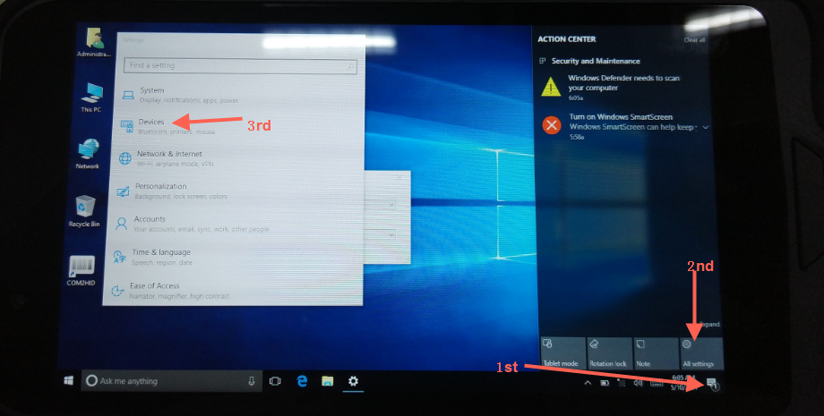

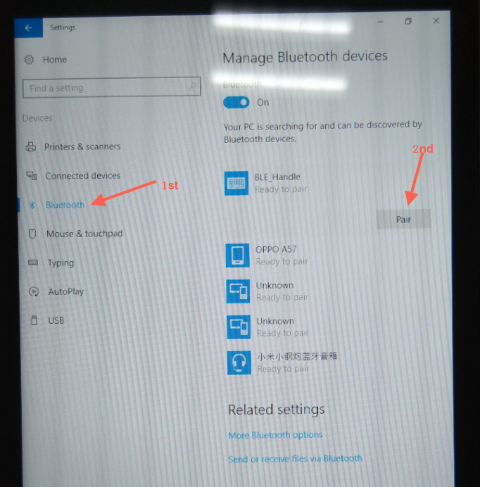

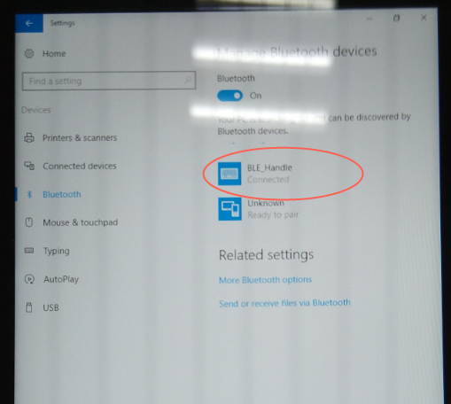

- Frequently Asked Question
- If the handle has been paired, then need to connect another machine, the following operations is needed:
i. Press and hold the scan key while turning on the power switch;
ii. When the power indicator on the handle flashes at 10S or so, the indicator light will be converted to flash at 1s, indicating previous paired device has been cleared successfully;
iii.At the moment you can release the scan button, search the Bluetooth deviceto connected the corresponding machine.

- bottom status bar does not exist scan application shortcut icon: restart the machine or click on the desktop scan application shortcut icon to restart the application.

- Scanning Shortcuts is repeatedat the bottom status bar: Click the Apply icon to clear the duplicate icon.

- After connected successfully, restart the machine and the handle light shows the flashing state for about 50 seconds. After the lamp goes out automatically, press the scan key to wake up the handle, and the handle will be connected with the machine automatically. Light keep on status means connection successfully!
- The app is installed only for I62H Windows. For Q62 Android, just connected with pistol grid in Bluetooth setting interface without app like the picture.

